This article assumes some knowledge on training data preparation; things like scaling, encoding, imputation, and feature engineering.

Many cases involve *periodic* (or *cyclical*) features. These are features that naturally have looping values; for example, time of day (24-hour cycle), seasons, angles of rotating bodies, virtual wraparound spaces, and most anything sinusoidal. Acceptable methods for handling these values are dependent on the algorithms employed. It is not appropriate to treat these attributes the same way as normal one-dimensional attributes because that makes the minimum and maximum values far apart spacially*, when they should be close.

*The formal spelling is “spatial”, but “spacial” is sometimes chosen because it more clearly references “space”.

**Neural Networks and Linear Regression**

The most common solution to use periodic data in a neural network is to transform each periodic attribute to a two-dimensional circle, so that the inputs are the sine and cosine of the angle.

Example for time of day

|  |  |  |
| --- | --- | --- |
| Time | Input A, sinΘ* | Input B, cosΘ* |
| Midnight | sin(0) = 0 | cos(0) = 1 |
| 3 AM | sin(π/4) = 0.7071 | cos(π/4) = 0.7071 |
| 9 AM | sin(3π/4) = 0.7071 | cos(3π/4) = -0.7071 |
| 2 PM | sin(7π/6) = -0.5 | cos(7π/6) = -0.866 |
| 8 PM | sin(5π/3) = -0.866 | cos(5π/3) = 0.5 |

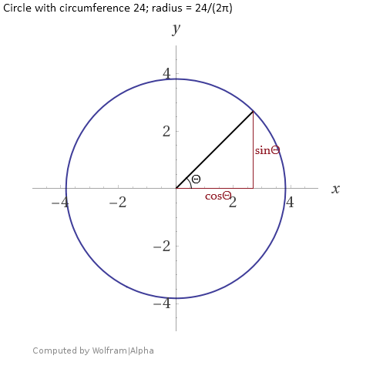*Multiplying by the radius, 3.8197, would be acceptable but unnecessary for most tasks.

Technically, this distorts the distance between values: Points on opposite ends of the cycle should be π•radius apart but are treated as if they are only 2•radius apart. This is acceptable for a neural network however, because it can find such non-linear relationships. Other supervised learning methods like linear regression also benefit from this approach; in these cases, it may be helpful to keep this distortion in mind while searching for a good model. Modeling sinusoidal relationships with (non)linear regression can be difficult but having some contextual knowledge of the data makes the process much easier.

Adjusting the radii of the attributes is unnecessary because the final coefficients or weights will fit themselves accordingly. Getting the radii right will usually take more effort than the time doing so saves.

Although a network with at least one hidden layer can approximate sinusoidal functions with common activation functions, some neural networks have used sinusoidal activations like sinc and sine. For example, https://www.researchgate.net/publication/3835580_Neural_networks_with_periodic_and_monotonic_activation_functions_a_comparative_study_in_classification_problems. No one activation function performs best at all jobs and sometimes uncommon activations work better.

Training a neural network to predict periodic values <…>

**Computing Distance**

Many algorithms rely on distance measurements. These include K-Nearest Neighbors and clustering algorithms like DBSCAN and K-Means. The distortions from using the trigonometric transformation described in the previous section are suboptimal for most of these algorithms. A type of cosine similarity can work but comes with its own issues that will be demonstrated later.

A flawless and simple solution for computing distances involving periodic attributes is to use the shortest distance along each periodic attribute to the neighboring point. Aside from attribute scaling, this is all that is needed because most if not all distance metrics use the differences along each dimension independently; for example, the Pythagorean theorem takes the square root of the sum of the squared differences to find the Euclidean distance.

Precise implementation will vary, but the approach is to take the absolute difference between the points along the dimension and if the dimension is periodic and the difference is greater than half the length of the period, subtract the length of the period and return the absolute value.

$$distance between x_{0} and x_{1} along cyclical dimension x= \left\{\begin{aligned}{||x}_{1}-x_{0}|-{(x}_{max}-x_{min})|, |x_{1}-x_{0}| > (x_{max}-x_{min})÷2 \\ \left|x_{1}-x_{0}\right|, otherwise\end{aligned}\right.$$

It can be expensive to constantly compute the distance between a point and all others, especially when conditional checks are involved. One way to reduce computation is to compute a full distance matrix for later reference. Not only does the matrix only need to be computed once, but math on matrices can be parallelized. Precomputed distance matrixes are often the only way to supply a custom distance metric to a library function. Supplied below are functions written in R and Python for building a distance matrix when periodic attributes are involved:

# R Script

# Returns distance matrix ("dist" class) for data points, when some values belong to periodic/cyclical attributes.

# E.g. 23:59 is only one minute away from 00:00, not 23 hours and 59 minutes.

periodic_dist <- function(dat,

ranges = NULL,

diag = T, upper = T) {

# Check arguments

if (sum(class(dat) %in% c("data.frame", "tbl_df", "tbl")) < 1) {

stop("\nArgument 'dat' should be a tibble or dataframe.")

} else {

# This shouldn't happen, but if I can make the mistake someone else might.

if (sum(class(dat[[1]]) %in% c("data.frame", "tbl_df", "tbl")) > 0) {

stop("\nIt appears you supplied a tibble containing a dataframe or tibble.\n",

"Did you use tibble() instead of as_tibble()? Try nameOfYourData[[1]].")

}

}

if (is.null(ranges)) {

warning("\nArgument 'ranges' not provided.\n",

"All columns treated as periodic and set column ranges to lowest and highest values.")

ranges <- list()

for (col in dat) {

# Append vector to list

ranges <- c(ranges, list(range(col)))

}

} else {

if (class(ranges) != "list") {

stop(paste("\nProvide argument 'ranges' as a list of vectors and values describing each column.",

"If a column is periodic provide a min and max vector, like c(1, 12) for month, or a single range value (computed by min - max), like 2*pi for angle.",

"If a column is not periodic, provide NA.",

"Example: list(c(0,1), c(1,12), 2*pi, NA)",

sep = "\n"))

}

}

# Initialize distance matrix

distances <- dist(rep(0, nrow(dat)), diag = diag, upper = upper)

for (i in 1:length(dat)) {

col_dist <- dist(dat[i], diag = diag, upper = upper)

if (sum(is.na(ranges[[i]])) < 1) {

# Replace values greater than half the possible distance

# with the remaining distance

range_val <- ranges[[i]]

if (length(range_val) > 1) {

range_val <- range_val[2] - range_val[1]

}

too_high <- which(col_dist > range_val/2)

col_dist[too_high] <-

abs(range_val - col_dist[too_high])

}

# cat("col_dist", col_dist)

# Increment distance^2

distances <- distances + col_dist^2

# cat("\n", distances)

}

# Complete distance formula by taking square root

return(sqrt(distances))

}

# Python Script

import numpy as np

from scipy.spatial import distance_matrix

import pandas as pd

import warnings

"""

dat:

A pandas dataframe or object that can be converted into pandas dataframe

ranges:

A list describing each column using any of these elements:

Float or integer that indicates the length of the period.

A list or tuple containing the min and max values of the period.

None. Indicates that the column is not periodic.

"""

def periodic_distance_matrix(dat, ranges = None):

if type(dat) != pd.core.frame.DataFrame:

dat = pd.DataFrame(dat)

if type(ranges) == type(None):

warnings.warn("No range information supplied. " +

"Taking max-min for each column.")

ranges = []

for col in dat:

ranges.append(np.ptp(dat[col]))

else:

if type(ranges) != list:

raise ValueError("Argument 'ranges' needs to be of type list.")

ranges = [np.ptp(r) if type(r) == list or type(r) == tuple

else r for r in ranges]

print(ranges)

distances = np.zeros((dat.shape[0],dat.shape[0])).astype('float64')

for i in range(dat.shape[1]):

values = dat.iloc[:,i].values.reshape(len(dat), 1)

col_dist = distance_matrix(values, values)

if ranges[i] != None:

col_dist[col_dist > ranges[i]/2] -= ranges[i]

distances += col_dist**2

return np.sqrt(distances)

**What Ifs**

One might choose to use more than two transformations. For example, three evenly spaced trigonometric transformations are sin(x), sin(x+2π/3), and sin(x+4π/3). This has no benefit as it creates a parameterized circle in three dimensions instead of two, which is subject to the same distortions at the cost of greater complexity.

If all or most variables are periodic, one might consider computing distance by taking a type of angular distance as described:

$$pseudo-angular distance between points \overset{⃑}{a} and \overset{⃑}{b} with all cyclical dimensions=$$

$$\cos^{-1}{\frac{{\sin{\overset{⃑}{a}} }^{⌢}\cos{\overset{⃑}{a}}∙{\sin{\overset{⃑}{b}} }^{⌢}\cos{\overset{⃑}{b}}}{\left|{\sin{\overset{⃑}{a} }}^{⌢}\cos{\overset{⃑}{a}}\right|∙\left|{\sin{\overset{⃑}{b}} }^{⌢}\cos{\overset{⃑}{b}}\right|}}$$

$$\text{Where the values in} \overset{⃑}{a} \text{and} \overset{⃑}{b} \text{are converted to radians or degrees according to dimension range.}$$

$$\text{The} ^{⌢} \text{represents concatenation.}$$

When there is more than one periodic variable, this works better on trigonometrically transformed periodic variables than Euclidean distance, but it is still subject to its own distortions and is not helpful in situations where the distance must be precisely measured. The problem arises in the fact that the wraparound space created by tiling rectangles; it’s not a proper sphere. This pseudo-angular distance metric might be more convenient in some cases or bring marginal calculation speed benefits, but this is still an inferior approach to the conditional algorithm provided previously because it doubles the number of dimensions to do an otherwise simple task. The graphics below show the behavior of the Euclidean (without trigonometric transformation, using an IF statement) and pseudo-angular distance measurements. Note: The spacing between contour lines is not precisely the same between the two plots. There’s something with geom_contour I would need to correct.

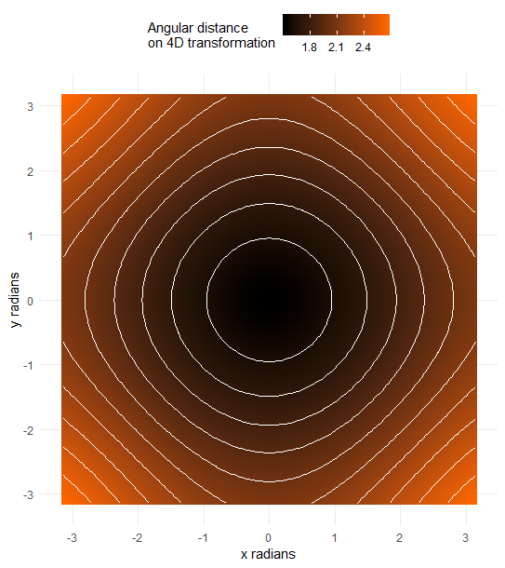

**Extras**

The geometries created by wraparounds are fascinating. If two periodic variables are to be continuously expressed in three dimensions, it can only be done using a torus. A less distorted mapping exists in 4D space (The angular distance as demonstrated above causes me to think that there is some distortion, but I have not proven it). Some attempt has been made to demonstrate this shape.

After further searching, I found that this is called a Clifford torus, belonging to a family of tori in even-numbered spaces. A proof for the Euclidean distance can be found here: <https://math.stackexchange.com/questions/965654/distance-between-two-points-on-the-clifford-torus>

Articles that may be of interest:

DOI: 10.1142/S0218001409007338